Shaver’s Creek Costume Contest
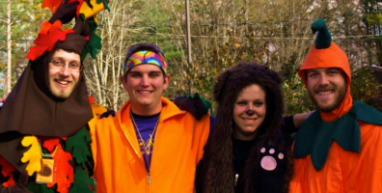
Shaver’s Creek
Pumpkin Carving Contest!

Contest Rules:
- Contest is open to ages 18 and younger during the event
- One entry per person
- Entries accepted 11:00 a.m. – 4:00 p.m. Saturday and Sunday
- Costumes are to be worn to the event; they are not provided
- One entry form must be completed by each contestant
- One winner will be chosen for each day of the Festival
- Winner will be notified via phone by November 1st
- Costumes will be judged on overall appearance, style & creativity

Prizes
- A nest box suitable for your home/land installed and checked the following season
- One 25% off coupon to use in the Shaver’s Creek Bookstore
- - - - - - - - - - - - - - - - - - - - - - - - - - - - - - - - - - - - -
COSTUME CONTEST ENTRY FORM

Name: _________________________ Phone Number: ___________

Address: _________________________________________________

PERMISSION TO PHOTOGRAPH: I, the undersigned, give my permission for ________________ to be photographed while participating in Shaver’s Creek programs. I understand the images may be used by The Pennsylvania State University and Shaver’s Creek in promotional materials or publications, and release Penn State and Shaver’s Creek from responsibility for any violation of personal or proprietary right I may have in connect with this use.

______________________________ ______________
Signature Date
Shaver’s Creek Costume Contest
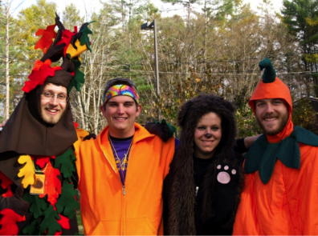
Shaver’s Creek
Pumpkin Carving Contest!
Shaver’s Creek Costume Contest
Shaver’s Creek
Pumpkin Carving Contest!
Shaver’s Creek Costume Contest
Shaver’s Creek
Pumpkin Carving Contest!

Contest Rules:
- Contest is open to ages 18 and younger during the event
- One entry per person
- Entries accepted 11:00 a.m. – 4:00 p.m. Saturday and Sunday
- Costumes are to be worn to the event; they are not provided
- One entry form must be completed by each contestant
- One winner will be chosen for each day of the Festival
- Winner will be notified via phone by November 1st
- Costumes will be judged on overall appearance, style & creativity

Prizes
- A nest box suitable for your home/land installed and checked the following season
- One 25% off coupon to use in the Shaver’s Creek Bookstore
- - - - - - - - - - - - - - - - - - - - - - - - - - - - - - - - - - - - -
COSTUME CONTEST ENTRY FORM

Name: _________________________ Phone Number: ___________

Address: _________________________________________________

PERMISSION TO PHOTOGRAPH: I, the undersigned, give my permission for ________________ to be photographed while participating in Shaver’s Creek programs. I understand the images may be used by The Pennsylvania State University and Shaver’s Creek in promotional materials or publications, and release Penn State and Shaver’s Creek from responsibility for any violation of personal or proprietary right I may have in connect with this use.

______________________________ ______________
Signature Date

